Space, Time, and Attention
November 17, 2019
The Rev. Dr. Susan Gilbert Zencka
Frame Memorial Presbyterian Church

Texts: Isaiah 65:17-25; Acts 17:16-29
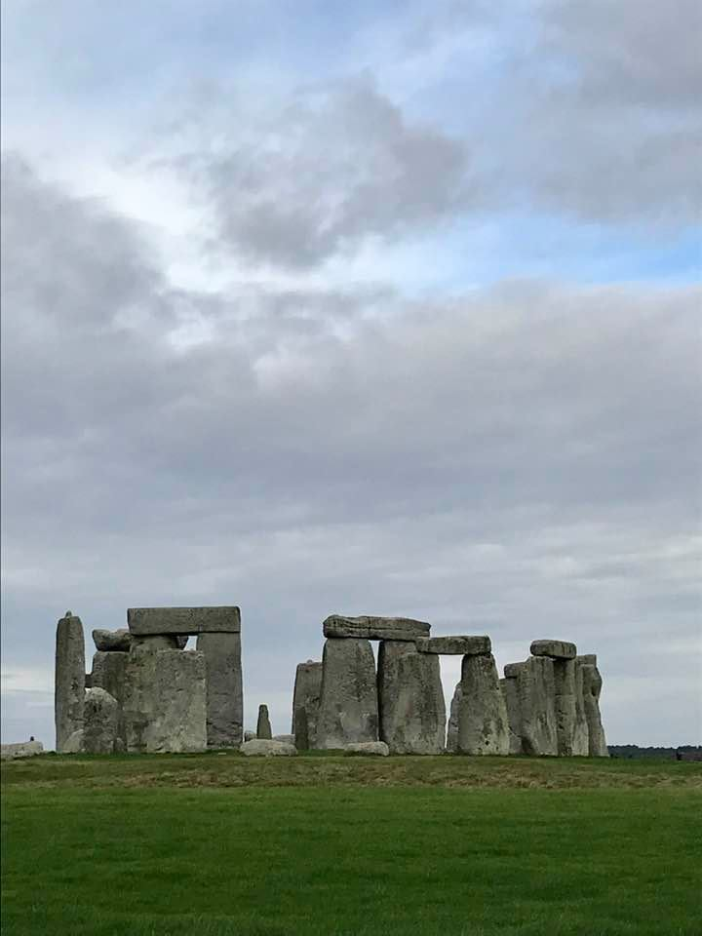
The Neolithic Era began about 12,000 years ago and ushered in a new age for humans, one in which we shifted from and hunting and gathering culture to beginning to develop agriculture, and settle into more stable communities. During this period, humans began to use tools, and pottery first developed. Late in this era, about 4,500 years ago in Southern England, people gathered two different types of stone, a golden stone called sarcens and another stone known as bluestones, and arranged them in a pattern of concentric circles. The sarcen stones weighed about 25 tons apiece and are thought to have been transported from about 20 miles away. The bluestones weighed on average about 4 tons apiece, but they came from Wales, about 180 miles away. How did the Neolithic people move these giant stones that distance? How did they stand them up? We don’t really know the answers to these questions. We also don’t know the purpose of the circles at Stonehenge, but we do know that they line up with the summer solstice sunrise. Clearly the people had recognized some order in the world around them, and they found some ritual meaning in connecting with that order.

Over the ages since then, humans have been paying attention to the world, trying to understand it, seeking to find order in the world, and making meaning by connecting with that order. Sixteen years ago, I was driving in Minnesota with two of our sons, who were 13 and 16 at the time. I said to the boys something like, “One of the nice things about driving is that you can see all kinds of interesting things in nature.” You could almost hear their eyes rolling at their mother’s thoughts on being in the car. We came around a corner and right ahead of us, it looked like there was an opening in the sky, a fissure, and the sunlight pouring through it. I stopped the car, we all stared in amazement, dumfounded. And as I saw this baffling sight, I felt a strange kinship with primitive peoples who might have seen strange things for which they had no explanation. I certainly had no way to explain what we were seeing. I took pictures of it, and as we drove further, we saw that there was actually a full arc. 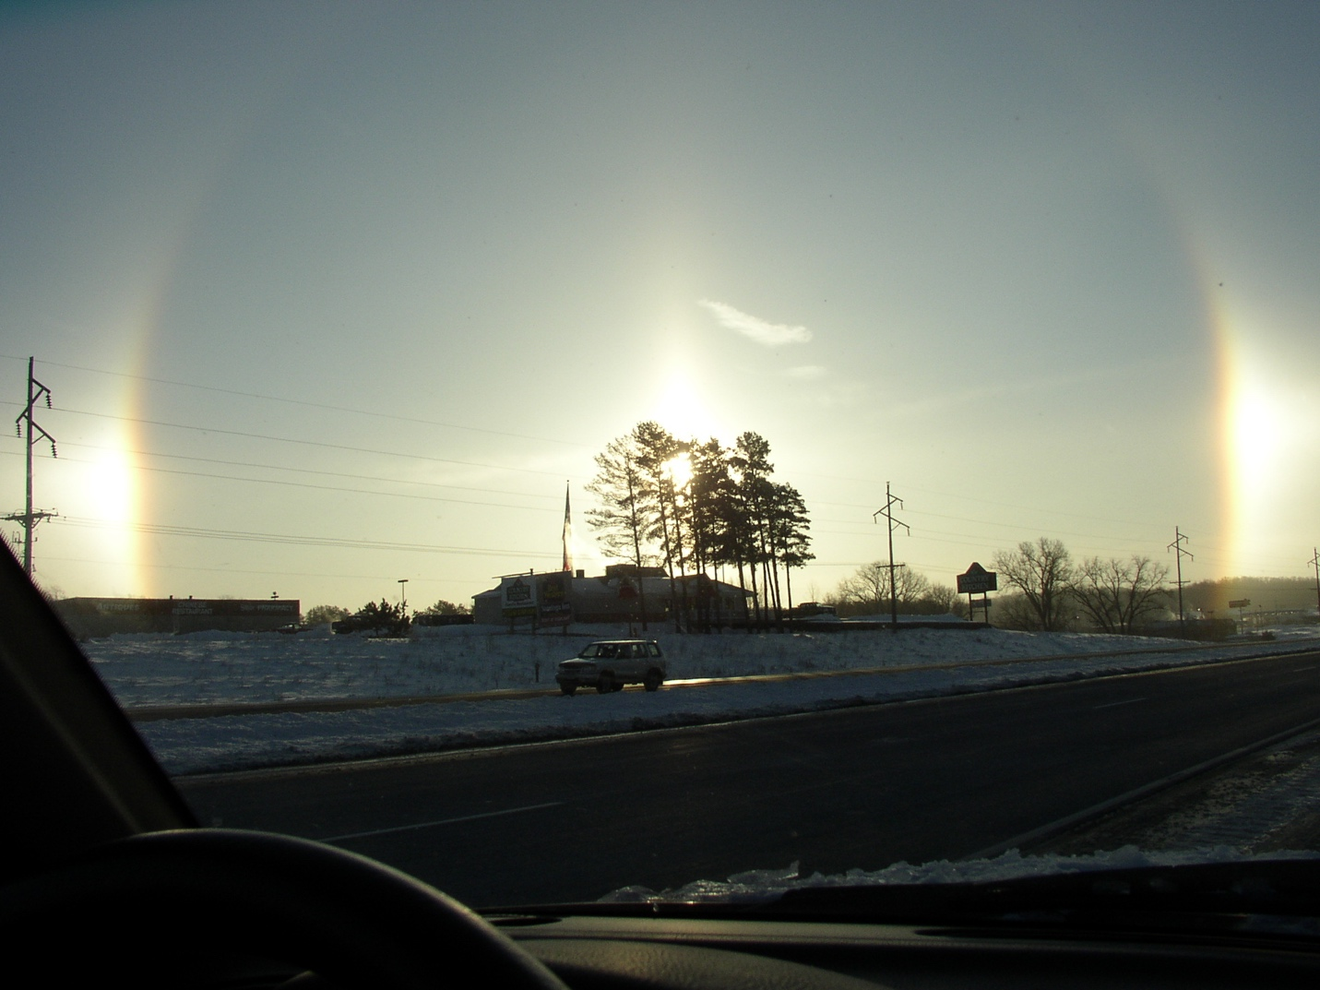You have one of my photos of this in your bulletin. We called it a sunbow, and learned later that it was actually a phenomenon known as sundogs, caused by ice crystals in the air, and that we had seen a classic example of it.

What we call science is really this: paying attention to the world and and trying to understand it. And science has changed a lot over the years. Two of the more fascinating classes I took during college were in the History of Science department—I didn’t even know that was a field before college. There are only 50 universities in the United States who offer graduate degrees in History of Science, and roughly half of those are within History Departments. It is a rare school that has a dedicated History of Science Department, and it is a fascinating field. But I digress.

The way we have understood the world has changed over the years and we are continuing to change our understanding. As some of you know, I have some interest but very little education in physics, so I’ve been reading a lovely little book called Seven Brief Lessons on Physics by Carlo Rovelli in an attempt to gain a little understanding. And so far, a little understanding is where I am in my physics studies. What I have learned is that things are not what they seem, but then, we knew that.
The earth seems flat, but instead it is round.
It seems like the sun rises and sets, but instead the earth rotates.
It seems like objects are solid and stationary, but they are actually comprised of atoms that are constantly in motion.
It seems like the earth is standing still, but instead we know that it is rotating around a central axis even as it travels around the sun.

Carlos Rovelli writes about science, “Science begins with a vision. Scientific thought is fed by the capacity to ‘see’ things differently than they have previously been seen.” I’m not sure I agree with him that science begins with a vision. I think that science begins with paying attention. Perhaps that’s what he means. I agree wholeheartedly that scientific thought is fed by the capacity to see things differently than they have previously been seen. That is huge. And it is harder than we think.

Over the last two weeks, I was visiting the United Kingdom. I was there for ten days: taking a class for five days, and taking the other five days to travel on my own. I visited two places that I had first visited 50 years ago with my parents and brother—Salisbury Cathedral and Stonehenge; and I visited some other places I had never been before, driving about 320 miles in all. I had driven in the UK before, eight years ago when Corey and I drove from Oxford to Scotland and back. Driving in the UK is complicated, because they drive on the left side of the road, and so their cars have the steering wheel on the right. The gear shift is on the left, and I drove cars with manual transmissions both times. Driving has become pretty automatic for me here, no pun intended, and I am a confident driver. I enjoy driving. But in the UK, just those little changes completely transformed my driving experience. I was like a brand-new driver all over again. It took every brain cell on alert to drive. I had to carefully monitor myself—as I started out from Heathrow, I was in a multi-lane, limited-access highway. But I noted that if I didn’t pay very close attention, the car would inevitably start to drift toward the left because I am used to my head being on the left side of a given lane of traffic. In the UK, however, driving from the righthand side of the car, my perspective shifted: I was now looking at the road from the righthand edge of a given lane of traffic. Add that to shifting gears with my left hand, going around roundabouts clockwise instead of counter-clockwise, country lanes being much narrower, and, well, you get the idea. But it wasn’t until I thought back to my earlier experience of driving in the UK that I realized how unsettling these changes were.

It is well-known in legal circles that eyewitness testimony can be notoriously inaccurate, because the brain creates changes in our memories. As I thought back to when Corey and I drove to Scotland and back, in my memory, it was just like an American car, with me on the driver’s side on the lefthand side of the car, and Corey sitting in the passenger side on the righthand side. I know that in fact it was the opposite, but my brain has normalized the memory to fit in with my usual driving experience. Our brains like consistency. We resist new ways of thinking. I’m glad to be back to driving the way I am used to! That experience has given me great admiration for people who are able to think in new ways about things, or to see things differently.

So to get back to physics, it turns out that instead of objects being fixed and separate from one another, the real constants in life, from the smallest quarks up to the largest solar systems, are that objects are always in motion, and in relationship to one another. Relativity—being in relationship—is one of the attributes of the physical universe. So is change. Humans seek stability—even humans like me who like change.

If we take seriously that there is some creative loving energy in the world, an energy we call God, we should be keenly interested in the world, the real world. Our faith should be reality-based and engaged with the real world, this real world that pulses with the energy of God. The Hebrew prophets were engaged with the real issues of the real world. Isaiah was concerned with just relationships in ancient Israel, with real economic relationships, and health conditions for people. Jesus addressed the political realities of living in a land occupied by Roman soldiers and spoke against the oppressive economic realities of the cult of sacrifice around the Jerusalem temple. Paul in preaching to the people of Athens spoke to the particular philosophical context of Athens.
At the heart of Christianity is the theological concept of incarnation—and that doesn’t just mean that Jesus made God visible to us. It means that our faith is always lived within the flesh-and-blood realities of the world. Our faith is engaged with the real world, not separate from our lived lives. And as people of faith, we are called to deal with facts as they really are, not as we might wish them to be.

And so the scientific realities of the world cannot contradict our faith, or our faith has got it wrong—ours is a reality-based faith. It’s about how we are really called to live in the real world where God is really present, a living God who calls us to engage with our real faith in ways that really make a difference, to our own experience and to the world. So if the real world is a dynamic rather than static reality—one in which change is a constant, then God is calling us to learn to engage change. And if the real world is one in which everything is interdependent and related to everything else, then part of our discipleship is the way we live out our relationship to earth, to one another, and to all God’s creatures.

And so paying attention to real life in the real world is a huge dimension of our faith—as the folks in the Scottish Church of Iona have written in one prayer, “If, however, we have driven a wedge between piety and peacemaking, erected a wall between prayer and politics, associated the purposes of heaven with only the gentler things of earth—God of justice, show yourself.” Our faith, and the practice of our faith must be reality-based and world-engaged. While the church should not be partisan, we absolutely should be engaged in the real work of justice in the world, and yes, that involves being involved in the political processes of the world—politics has to do with how things actually get done in the exercise of power in nations. Partisan, no; political, yes.

And in this season of stewardship, it is important to remember that our faith should guide our giving and spending in this real world as well. How are we called to support the mission of God in the world? How are we called to mirror God’s generosity to the world? How can we support God’s mission through Frame Church in our giving of our time, our talents, and our treasure?

So—back to science: how can we develop in ourselves the capacity to see the world in new ways? Jesus consistently challenged people to see the world, and to see themselves, in new ways. That is the crux of faith—to rely on God, to trust in that dynamic energy of love, that creates, redeems, and sustains the world, to continually recreate us, to redeem us, to sustain us in all the ways that matter. If we are relying on someone or something else for our security, we have made an idol out of that something else—even if it is the Bible, or the church, or the way we have always done things. The essential energy of the world does not stand still.

As God said through the prophet Isaiah in chapter 43, “Do not be afraid…I have called you by name, you are mine. You are precious in my sight, and I love you…Do not remember the things of old. Behold, I am doing a new thing!” I have experienced this dynamic God-energy lovingly calling me from the security of where I am to the freedom of a new thing—when I went to seminary 25 years ago, when we came to Wisconsin 13 years ago, when I studied for my doctorate, and most recently when I began studying Internal Family Systems to enlarge my ministry. When we put our trust in God instead of who and how we have been, God can lead us in powerful new ways. Creation is an ongoing process, not a one-and-done with the Big Bang 13.8 years ago or with our own births whether 6, 16, or 96 years ago. God called life into being over the ages. And once there were humans, God wasn’t done with us. In the Neolithic period, God called our forbearers to try a new thing—forming stones into tools, planting seeds in the ground, and making sense of the world in new and different ways.

When I was in England, at Salisbury Cathedral I saw one of the original copies of the Magna Carta—a new way of humans sharing power, limiting the power of kings and creating the rule of law. Again and again through the centuries, men and women have answered the call of God to create new ways of being together, or to defend the rights of those without power, or to steward the earth in new and different ways. In our own day, we are called to defend the importance of science, the rule of law, and to care for the earth in ways that humans have never had to do before. There are huge challenges before us as men and women—and for some of us, to answer the call will mean seeing ourselves in new ways, understanding our nation or our politics differently, finding new ways of eating, cooperating with others, or spending our money.

As a church, in recent years we have been called to new ways of showing hospitality to organizations who are feeding our community, and sheltering those on the very margins of our community. How might we each be called to deeper levels of giving in the coming year so that we can update our kitchen, replace old carpeting, and care for this building through which we have shared ministry in Portage County? We have a different kind of youth group than most churches, one that welcomes all youth regardless of faith or membership, one that welcomes questions at the most basic level. We are not a church that relies on agreeing with traditional doctrine, but we have been a church that exercises welcome to new ideas, and to people who were not welcomed by other churches. We have been a church that relies on the dynamic energy of love to bind us together. In this love we live and move and have our being, as we have been, and as we will be. Amen.

Science and Imagination

What harm in saying that the sun rises
Or a star falls across the velvet sky,
Just because science contradicts the eye
And logic edits the old surmises?

Dare we deny biology’s decrees
That love is merely evolution’s curse,
The heart’s great rage and ache simply a verse
Of genes composed across the centuries?

And tell what effrontery there would be
If we professed a soul, and further claimed,
That when the flesh unbreathed, the soul remained,
Science blinded by what it cannot see?
Reason plods while imagination soars
And fills the vacuum that nature abhors.

~ Richard H. Behm ~

The photos and this poem were included in the worship bulletin for November 17, 2019 as were the following prayer and affirmation.

UNISON PRAYER OF CONFESSION
O God, how often we have shrunk faithfulness to mean only what we believe about you, and only what we do in church. Forgive us. You are God of all life and all creation, and yet we behave as if some areas of knowledge, like physical science, economics, and political science, have nothing to do with you. Worse, we convince ourselves that our choices in how we spend our money, how we spend our time, and what we think about aren’t part of how we live out our faith. We fragment our lives, and then are surprised to find ourselves broken. Heal our sense of the world, O God, and lead us into lives of wholeness and holiness. Amen.

WORDS OF AFFIRMATION
The woods, the laboratories, the libraries—all are part of God’s realm;
And we all, throughout the world, are God’s people. God’s spirit flows through us, among us, around us, uniting us to all life. We are all included. Everything belongs

